AI Coding Assistants POC Using Claude Code

Table of Contents
- Objective
- POC Architecture
- Epic — AI Coding Assistants Using Claude Code
- User persona impacted by the POC
- Functional Requirements
- Non-Functional Requirements
- AppScan MCP Tool Inventory
- Workflow-to-Tool Mapping
- Phase-1
  - Story 1 — AppScan MCP Integration
  - Story 2 — Claude Code AppScan Agent
  - Story 3 — Claude Integration
  - Story 4 — Remote and Local MCP Support
  - Story 5 — AI-Assisted AppScan Remediation
  - Story 6 — POC Packaging & Documentation
- POC Deliverables
- Scope Alignment with Original Feature Set (Phase 1)
- Explicitly Out of Scope for Phase 1
- POC Success Criteria for Phase 1
- Scope Principle
- Phase-2
- Critical Open Questions – Updated Assessment

Document Review History
Reviewer Name | Version | Date | Status | Comments / Remarks
Vinita Sanghi | 1.0 | 2026-10-09 | Reviewed | Initial feedback and inline comments provided.
Ankur Raina (author) | 1.0 | 2026-10-09 | Updated | Addressed review feedback and technical details.

Objective
Build and validate a reusable AppScan Connector for Claude that consumes the existing HCL AppScan MCP and makes its available AppScan capabilities accessible through Claude Code, Claude Desktop and Claude Web. The connector will support both remote and local MCP deployment models and will demonstrate AI-assisted remediation using the capabilities already exposed by the AppScan MCP. The POC will not extend or modify the AppScan MCP.

POC Architecture
The POC has two related layers: the reusable AppScan Connector and the Claude Code-specific AppScan Agent. The connector provides the AppScan integration layer; the agent provides the slash-command-based developer experience in Claude Code.
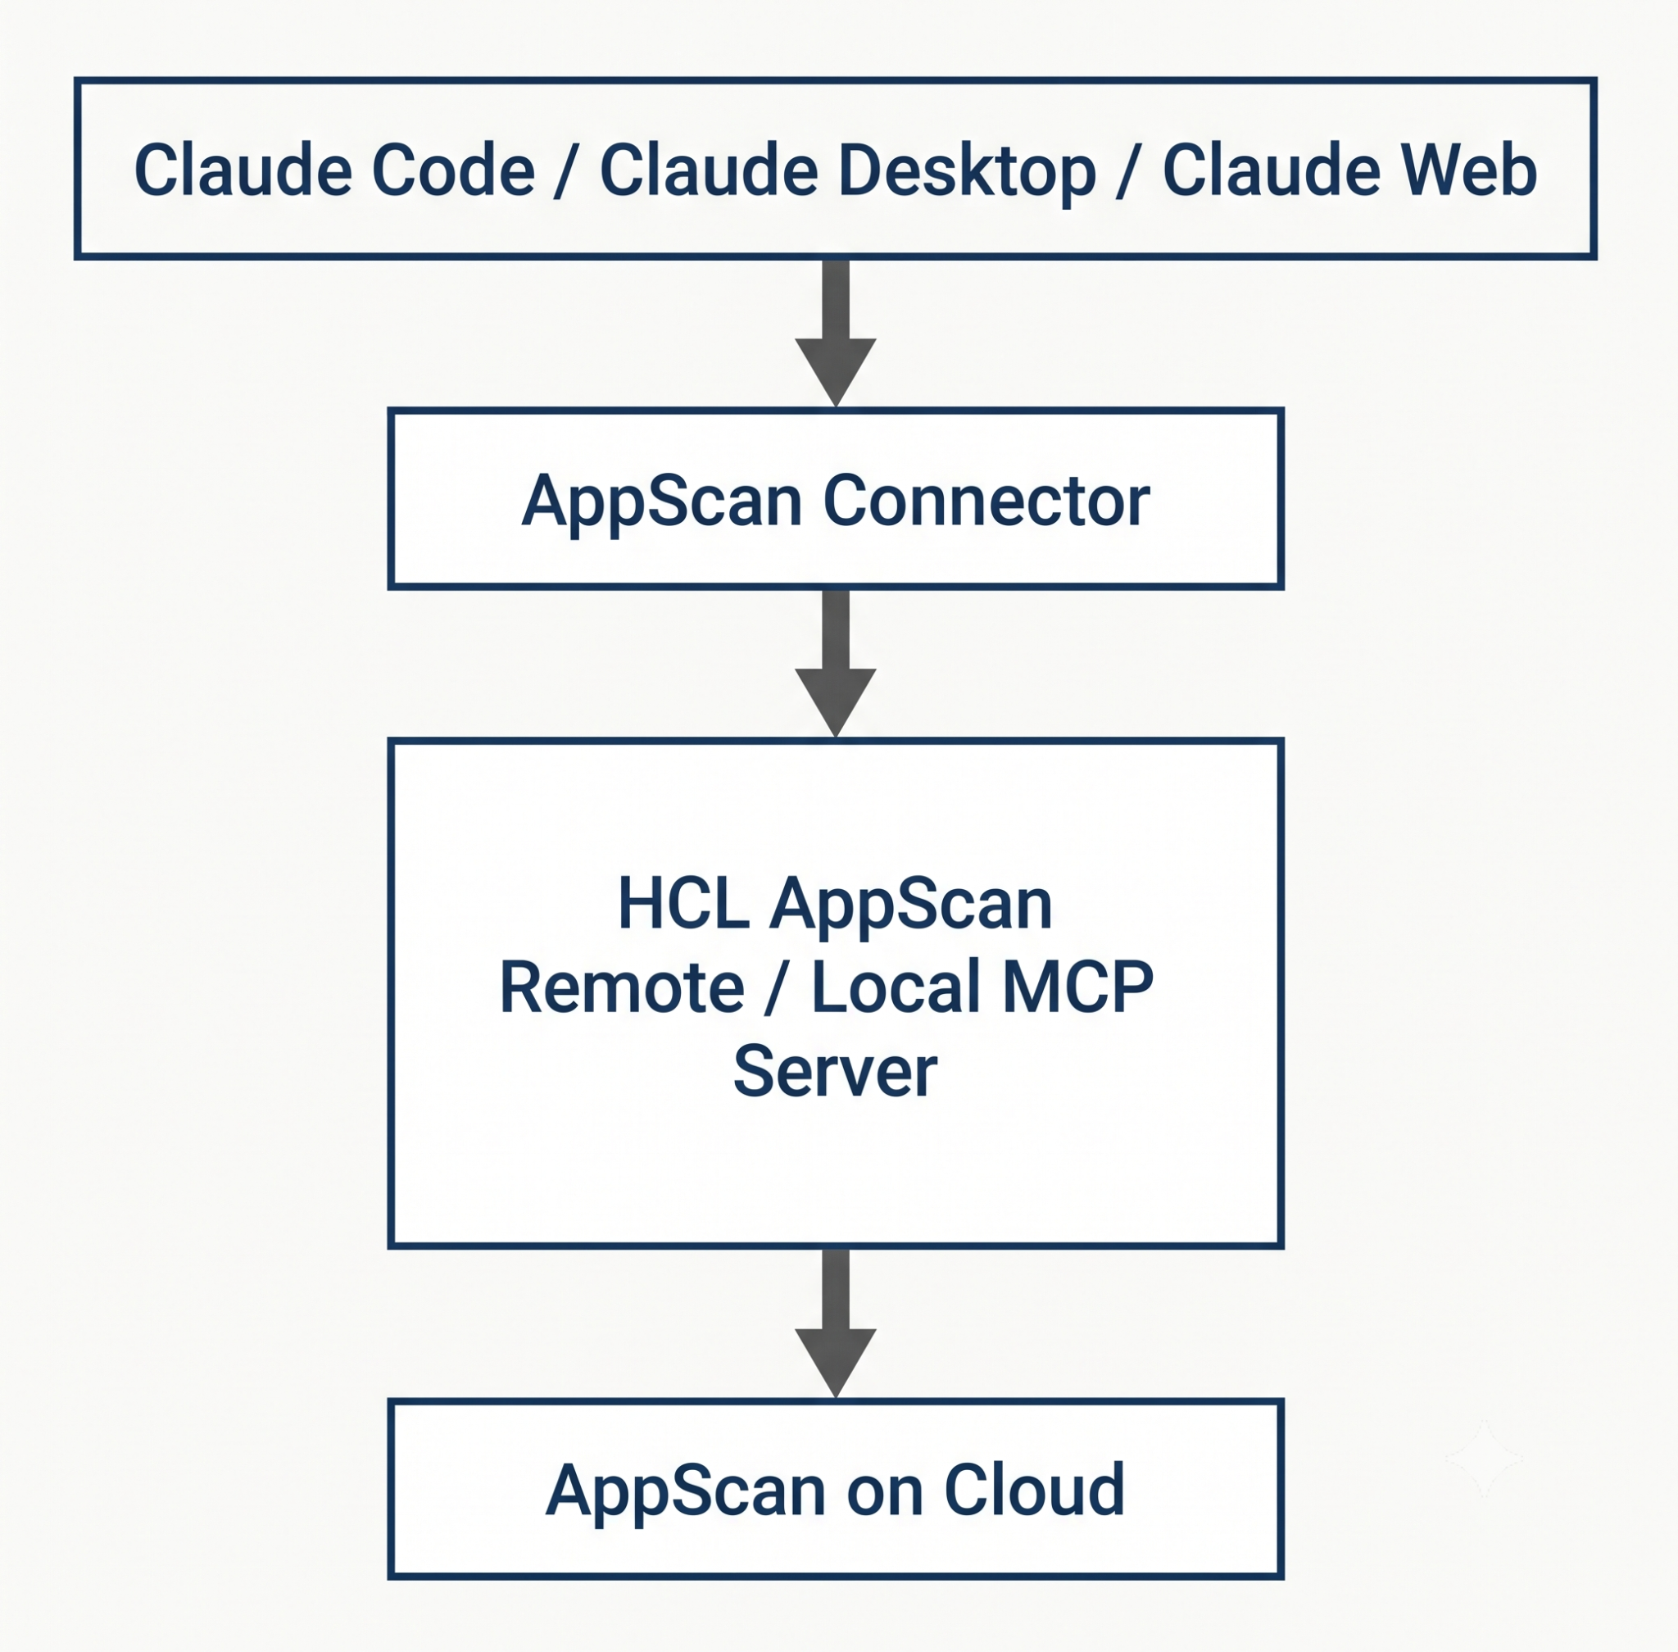

Epic — AI Coding Assistants Using Claude Code
Build and validate a single AppScan Connector backed by the existing HCL AppScan MCP. For Claude Code, the connector will be used by a specialized AppScan Agent that developers can invoke through slash-command-based workflows. The connector itself is not a new AppScan MCP server and does not add capabilities to the existing AppScan MCP.

User persona impacted by the POC:

User Persona | Requirement | Current POC Coverage | Status | Gap / Remarks
Developer | Real-time file-level security scanning | AppScan findings can be retrieved and analyzed through Claude | Partial | Current AppScan remote MCP does not support triggering scans on file changes. Need to validate if local MCP supports real time file level scanning
Developer | Quick-fix / remediation suggestions | Claude Code can use AppScan finding details, trace and remediation guidance to analyze local source and generate a fix | Covered | Core capability being demonstrated
Developer | Low latency (<5 sec per file scan) | No file-level scan is triggered by the POC | Not Covered | Cannot validate this requirement with the current AppScan remote MCP. Need to validate if local MCP supports real time file level scanning.
Developer | One-click remediation for common issues | Claude Code can generate and apply code changes based on an AppScan finding | Partial | AI-assisted remediation is demonstrated; fully automated one-click remediation is not a committed capability
Security Team / AppScan Owner | Enforce security policies in real-time across development | AppScan MCP supports policy-based filtering/analysis of findings | Partial | Policy-aware analysis is possible; real-time policy enforcement is not implemented
Security Team / AppScan Owner | Visibility into what developers are scanning and when | AppScan MCP provides application, scan and finding information | Partial | Scan information is available, but developer-level activity/usage telemetry is not implemented
Security Team / AppScan Owner | Periodic full-project scans for compliance | AppScan MCP provides scan information | Not Covered | Current AppScan MCP does not support scan triggering or scheduling, can be validated once the local MCP server is capable of running create scan
Security Team / AppScan Owner | Integration with ticket systems such as Jira | Not included in current POC phase 1. | Not Covered | Would require additional Jira integration / MCP chaining
Product Manager / DevOps | Differentiated AppScan offering | POC demonstrates Claude + AppScan integration and AI-assisted remediation | Partial | Demonstrates potential product differentiation; market validation is outside POC scope
Product Manager / DevOps | Clear ROI metrics | No measurement of time saved, remediation effort or earlier detection | Not Covered | Requires dedicated measurement/telemetry
Product Manager / DevOps | Easy adoption for existing AppScan customers | Uses existing AppScan MCP and AppScan authentication | Partial | POC validates the integration approach; production-ready onboarding is future scope
Product Manager / DevOps | Usage and impact telemetry | Not implemented | Not Covered | Future productization capability

Final verdict: Phase 1 will target the developers as primary users.

Functional Requirements
ID | Requirement | Description
FR-01 | MCP connectivity | Connect to the configured HCL AppScan MCP using supported transport and authentication.
FR-02 | Application discovery | Retrieve available AppScan applications.
FR-03 | Scan visibility | Retrieve scan information for a selected application where available.
FR-04 | Finding retrieval | Retrieve/filter findings using supported query parameters.
FR-05 | Issue details | Retrieve issue context including location, trace and remediation guidance where exposed.
FR-06 | Finding explanation | Claude Code explains the finding using AppScan data and local source context.
FR-07 | Remediation proposal | Claude Code proposes a code fix based on AppScan guidance and local source.
FR-08 | User-controlled changes | Code changes are reviewable and applied in accordance with user request/approval.
FR-09 | Configurable connectivity | Support remote/local MCP configuration through one connector; capability depends on the configured server.
FR-10 | Graceful limitations | Clearly report unavailable tools/actions instead of implying execution.
FR-11 | Optional issue update | Use update_issues only if issue-data/status updates are explicitly approved and in scope; not required for core remediation.

Non-Functional Requirements
ID | Attribute | Requirement
NFR-01 | Security | Do not hard-code or commit API credentials; use secure configuration and authorized access.
NFR-02 | Least privilege | Use only necessary tools. Treat update_issues as modifying data and require clear intent.
NFR-03 | Transparency | Distinguish AppScan-returned data from Claude-generated interpretation and proposed fixes.
NFR-04 | Reliability | Handle connection/authentication errors, empty results and unavailable tools with clear messages.
NFR-05 | Maintainability | Keep connector/agent instructions separate from the AppScan MCP implementation; do not duplicate AppScan business logic.
NFR-06 | Configurability | Do not assume remote and local MCP expose identical tools or schemas.
NFR-07 | Performance | Do not promise <5-second file scanning in this POC. Scan latency needs scan-triggering support and empirical testing.
NFR-08 | Remediation safety | Inspect source and provide a reviewable diff; do not claim a generated fix is secure without validation.
NFR-09 | Client compatibility | Validate Claude Code first; claim Desktop/Web support only after testing supported client configurations.
NFR-10 | Documentation | Maintain setup, architecture, tool mapping, assumptions and known limitations.

AppScan MCP Tool Inventory
The following 12 tool names were observed in the current remote MCP environment. Revalidate tool availability and schemas against the local MCP when it becomes available.
Tool | Purpose / Planned Usage
get_apps | List/retrieve applications; application discovery.
get_apps_by_library | Retrieve applications by library when library context is useful.
get_scans | Retrieve scan information and scan context.
get_issues | Retrieve/filter findings; summaries and triage.
get_issue_details | Retrieve detailed issue context, location, trace and remediation guidance.
update_issues | Modify issue information/status; optional and not required for core code remediation.
get_fixgroups | Retrieve fix-group information where useful.
get_policies | Retrieve policy information for policy-aware analysis; does not itself enforce policy in real time.
get_licenses | Retrieve license information if required; not a core workflow.
get_org_libraries | Retrieve organization library information if relevant.
get_os_libraries | Retrieve OS library information if relevant.
get_edm_metadata | Retrieve metadata/schema information where needed for supported fields and query semantics.

Workflow-to-Tool Mapping
Workflow | Tools / Responsibility
List/select an application | get_apps; optionally get_apps_by_library
Review scans | get_scans
Summarize findings | get_issues
Investigate a finding | get_issue_details; get_issues to locate/select the issue
Generate/apply a code fix | get_issue_details plus Claude Code local source inspection and code editing
Policy-aware analysis | get_policies plus supported finding retrieval/filtering; no real-time enforcement claim
Update issue status/data | update_issues only if explicitly approved and in scope
Create scan using future local MCP | Future only; exact tool name/schema and behavior must be verified when delivered

Phase-1: In this phase the POC will focus on the following points:
- Clean, robust and flexible architecture.
- All the relevant remote and local MCP capabilities. (Remote vs Local MCP)
- Ability to switch between remote and local MCP server.
- AI based remediations.

Story 1 — AppScan MCP Integration
Integrate the existing HCL AppScan MCP with the AppScan Connector.

Tasks
- Configure and authenticate the AppScan MCP.
- Integrate the connector with the existing MCP.
- Validate the capabilities already exposed by the MCP.
- Validate retrieval of supported AppScan security information, issue details and remediation information.
- Establish the connector interface for consuming those capabilities.

Deliverable
Working connector-to-AppScan MCP integration and capability mapping.

Story 2 — Claude Code AppScan Agent
Provide a Claude Code-specific AppScan Agent that uses the connector for developer workflows.

Tasks
- Create the AppScan Agent workflow for Claude Code.
- Provide slash-command-based AppScan workflows.
- Use the connector for AppScan finding and issue-related requests.
- Demonstrate finding explanation and remediation workflows.

Deliverable
Working Claude Code AppScan Agent using the connector.
Note: Scan commands such as '/appscan scan' are not included unless the required capability is already exposed by the existing AppScan MCP. The POC will not add scan capabilities to MCP.

Story 3 — Claude Integration
Make the connector available across the targeted Claude environments.

Tasks
- Integrate and validate the connector with Claude Code.
- Validate the connector with Claude Desktop.
- Validate the connector as a remote connector for Claude Web.
- Provide a consistent AppScan interaction model across supported Claude surfaces.

Deliverable
Claude integration demonstrated through Code, Desktop and Web, subject to each environment's supported connector model.

Story 4 — Remote and Local MCP Support
Support remote and local MCP through the same AppScan Connector.

Tasks
- Validate the remote MCP configuration.
- Validate the local MCP configuration.
- Use a common connector interface for both deployment modes.
- Document how the MCP mode is configured or switched.

Deliverable
One AppScan Connector demonstrated with both remote and local MCP configurations.

Story 5 — AI-Assisted AppScan Remediation
Demonstrate the core shift-left workflow using information already exposed by AppScan MCP.

Tasks
- Retrieve an AppScan finding through the connector.
- Retrieve available issue details and remediation guidance.
- Identify the affected source code in Claude Code.
- Generate remediation using the AppScan-provided information.
- Apply the remediation to the local source code.

Deliverable
End-to-end AppScan finding → MCP → Connector → Claude → local code → AI-assisted remediation.

Story 6 — POC Packaging & Documentation
Package the POC so it can be evaluated and used as the basis for future productization.

Tasks
- Document the connector and agent architecture.
- Document remote/local MCP configuration.
- Document supported Claude workflows and slash commands.
- Document POC findings, limitations and recommendations.
- Prepare an end-to-end demonstration.

Deliverable
Architecture document, setup/configuration guide, usage examples, demonstration, and POC findings/recommendations.

POC Deliverables
- Working AppScan Connector backed by the existing HCL AppScan MCP
- Claude Code AppScan Agent with slash-command-based workflows
- Remote MCP support
- Local MCP support
- Claude Code integration
- Claude Desktop integration
- Claude Web remote connector validation
- AI-assisted AppScan remediation demonstration
- High-level architecture and setup documentation
- POC findings, limitations and recommendations

Scope Alignment with Original Feature Set (Phase 1)
The POC covers the applicable capabilities from the original scope while explicitly documenting the current limitations of the existing HCL AppScan MCP. The connector will not add capabilities that are not already exposed by the MCP.

Feature 1 — File-Level Real-Time Scanning
Limitation for this POC: Not included. The current HCL AppScan MCP does not provide scan-triggering capability. The POC will therefore not implement file-level scanning or introduce a new scanning mechanism.

Feature 2 — Periodic Full-Project Scanning
Limitation for this POC: Not included. The current HCL AppScan MCP does not provide scan-triggering capability, so scheduled or on-demand full-project scans are outside the POC.

Feature 3 — Inline / AI-Assisted Remediation
Included. AppScan MCP provides the available finding, issue and remediation information. Claude Code uses that information together with the local source code to generate and apply the remediation.

Feature 4 — MCP Chaining
Not included in the current POC. Chaining with Jira, GitHub or other MCPs may be considered as future productization work.

Explicitly Out of Scope for Phase 1
- Adding, modifying or extending capabilities in the HCL AppScan MCP
- Implementing scan triggering or scan capabilities that are not exposed by AppScan MCP
- Building a second or separate connector for local MCP
- Native IntelliJ, Eclipse/STS or VS Code plugins
- Jira/GitHub integrations
- Marketplace publication
- Production-grade deployment and operations
- Automated file-save scanning

POC Success Criteria for Phase 1
- Claude can use the AppScan Connector to access capabilities exposed by the existing HCL AppScan MCP.
- A Claude Code AppScan Agent can provide AppScan workflows through slash commands.
- The same connector supports remote and local MCP configurations.
- The connector can be validated across Claude Code, Claude Desktop and Claude Web within their supported connector models.
- Claude Code can use AppScan findings and remediation guidance to identify and remediate vulnerable local source code.
- The resulting architecture is a viable foundation for future productization without extending the AppScan MCP.

Scope Principle
The AppScan Connector consumes and orchestrates capabilities already exposed by the HCL AppScan MCP. It does not extend the MCP or introduce new AppScan capabilities. Remote and local MCP are deployment options for the same connector, not separate connectors.

Phase-2: In the next phase the local MCP (when available) will have a create scan capability that will be a useful addition to the core capabilities of the MCP tool which in turn can be leveraged within the Claude connector and enhance its capabilities. The capabilities of the local server will have to be validated upon integration. This phase will also look to integrate the connector with JIRA for tracking.
The scope of work will be detailed once we move to phase 2 with the local MCP server ready with its capabilities.

Critical Open Questions – Updated Assessment

1. AppScan MCP Discoverability in Claude Code
Question: Is the AppScan MCP automatically registered when Claude Code loads, or does the developer need to manually configure it?
For the current POC, manual MCP registration/configuration is required. The connector should not depend on automatic discovery. Future packaging can simplify onboarding and potentially automate configuration.
Decision: Current POC: Manual configuration. Future: Simplified/automated onboarding should be considered.
Status: Answered for POC / Future enhancement
2. Application Context Resolution
Question: How does the AppScan Agent determine which AppScan application to use?
The connector needs a project-to-AppScan-application mapping. For the POC, the developer can specify or select the AppScan application. With future scan creation, this mapping becomes more important because the connector must know where a new scan should be created. The exact mechanism (.appscan.json, environment variable, application name, or first-use selection) remains a design decision.
Decision: Current POC: Explicit application selection/mapping. Future: Establish persistent project-to-AppScan application mapping.
Status: Design decision required
3. Scan Latency SLA & Caching Strategy
Question: What is the acceptable wait time for a file-level scan? Should results be cached, scans queued, or previous results shown while scanning?
The future local MCP's scan-creation capability makes scan triggering technically possible, but it does not guarantee a sub-five-second scan. The connector should cache existing findings, avoid rescanning unchanged code, support asynchronous execution for longer scans, and show the latest available results while a new scan is running. The actual SLA must be established through performance testing.
Decision: Current POC: No file-level scan latency measurement. Future: Validate latency, caching and asynchronous execution.
Status: Future design/performance validation
4. Remediation Data Detail
Question: What level of remediation guidance does AppScan MCP provide?
The AppScan MCP provides detailed issue information including vulnerability information, source/location, trace information and remediation guidance. HCL documents a workflow where AI retrieves issue details, maps the finding to local source code and generates/applies remediation. The POC has also validated this using the AltoroJ Cross-Site Scripting finding. AppScan provides security intelligence; Claude Code provides code-level reasoning and implementation.
Decision: AppScan MCP provides sufficient finding context for the POC's AI-assisted remediation workflow. Do not assume a ready-made code patch exists for every vulnerability.
Status: Answered
5. AppScan on Cloud Deployment Model
Question: Is this intended as internal HCL tooling, a product feature shipped with AppScan on Cloud, or a customer reference implementation?
The technical direction is a reusable AppScan Connector for Claude rather than a one-off AltoroJ implementation. The same connector should support remote and local MCP connectivity. Remote/local are connectivity or deployment options, not separate connectors. The final commercial/product packaging decision remains with Product Management.
Decision: POC objective: Validate a reusable connector architecture that can support both remote and local MCP. Future: determine final product/support model.
Status: Architecture direction established / product decision pending
6. Integration with Existing Security Workflows
Question: Should file-level scans block commits? Should results feed back into AppScan dashboards?
With future local MCP scan creation, development-time scanning becomes technically possible. Whether a finding blocks a commit is a security-policy/workflow decision. The connector currently consumes AppScan data rather than creating scan results. Dashboard behavior for locally initiated scans must be validated when the local MCP is available. Jira remains a separate future integration.
Decision: Current POC: Finding retrieval, analysis and AI-assisted remediation are in scope. Commit blocking and Jira are not. Future scan-triggered workflows require validation.
Status: Partially answered

